**HOTEL RESERVATION APPLICATION**

**PROJECT DOCUMENTATION**

The Hotel Reservation Application is a console application built with Java. It demonstrates basic Java programming concepts and principles of object-oriented design. The main goal of this project is to create a simple, functional hotel reservation system. It lets customers search for available rooms, create accounts, make reservations, and view their bookings. It also offers admin features to manage rooms, customers, and reservations.

This application uses core Java and follows a layered architecture. This architecture separates the system into models, services, resources, and user interface components. It heavily relies on object-oriented programming (OOP) concepts, including encapsulation, inheritance, polymorphism, and abstraction. Java Collections are used for storing data in memory, and exception handling is applied to ensure the application runs smoothly and avoids crashes from invalid user input.

The document includes **step-by-step explanations supported by screenshots**, showcasing how each component of the application was created and integrated. This structured documentation helps in understanding the development process, design decisions, and how OOP concepts are implemented throughout the project.

**Step 1: Create first package- Model**

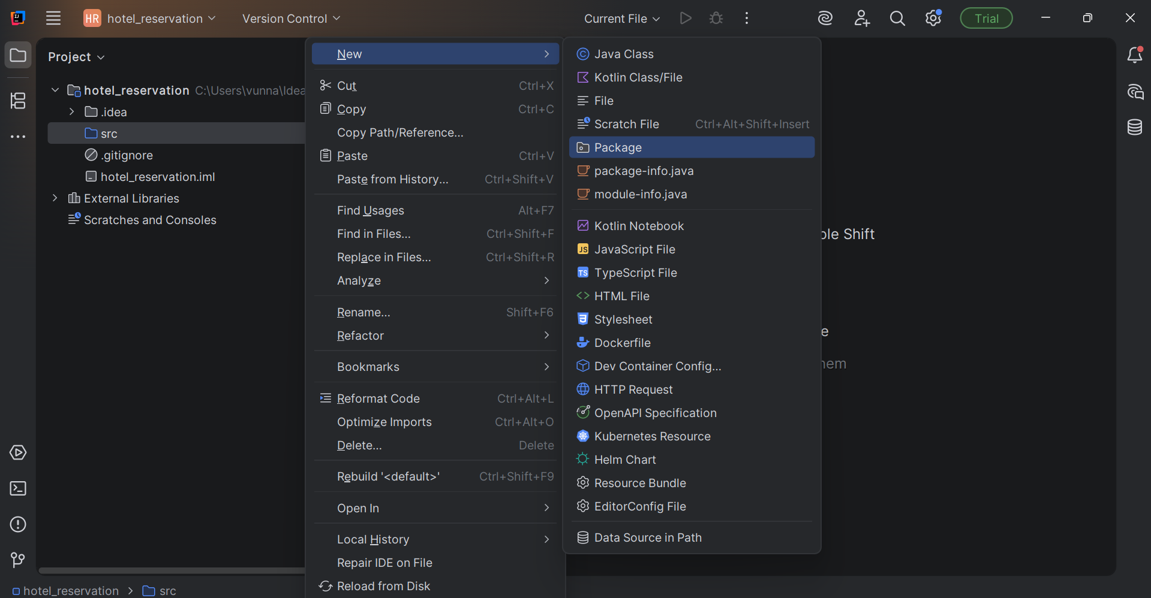

**Step 2: Create RoomType ENUM**

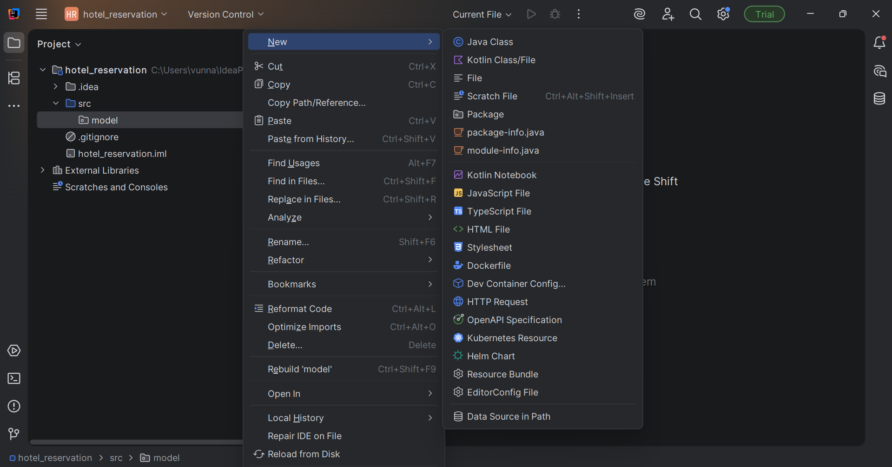

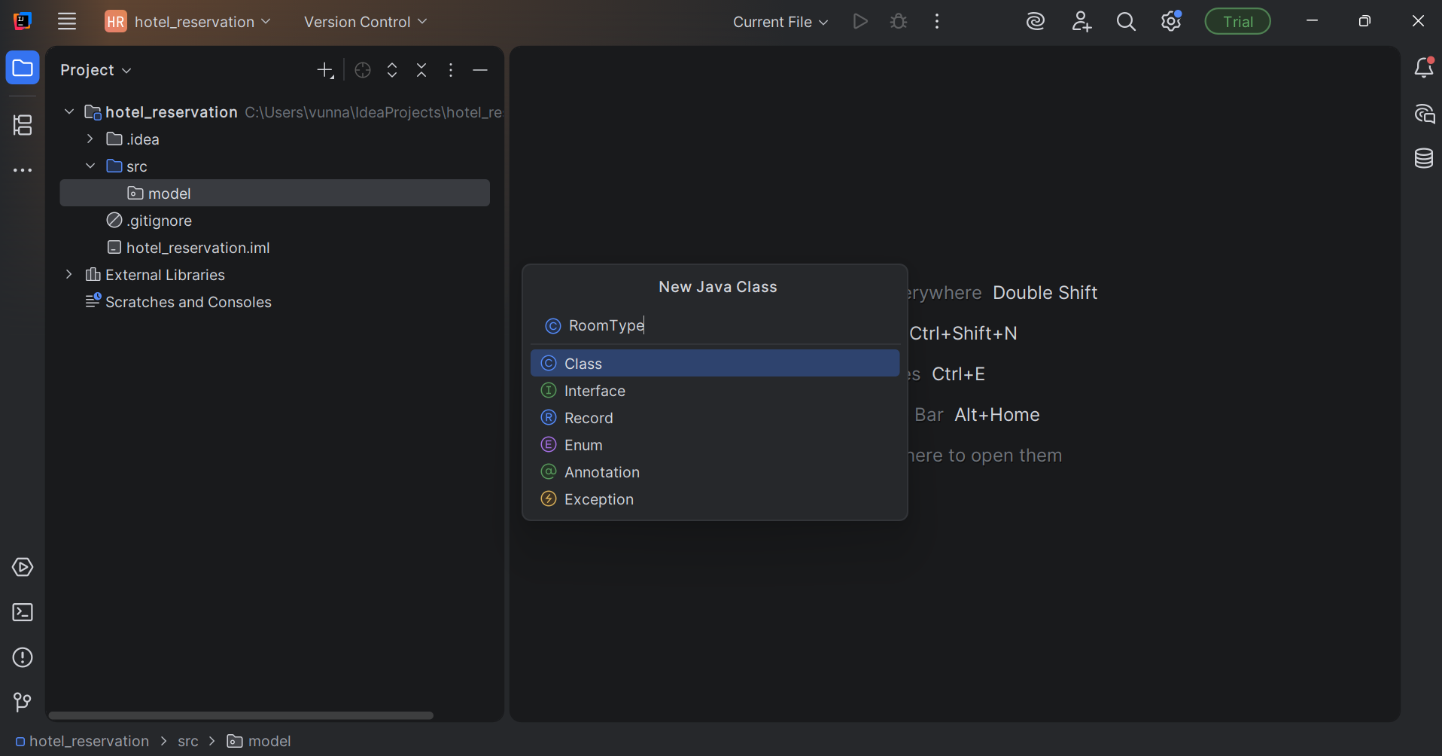

**Step 3: Enumeration class and RoomType**

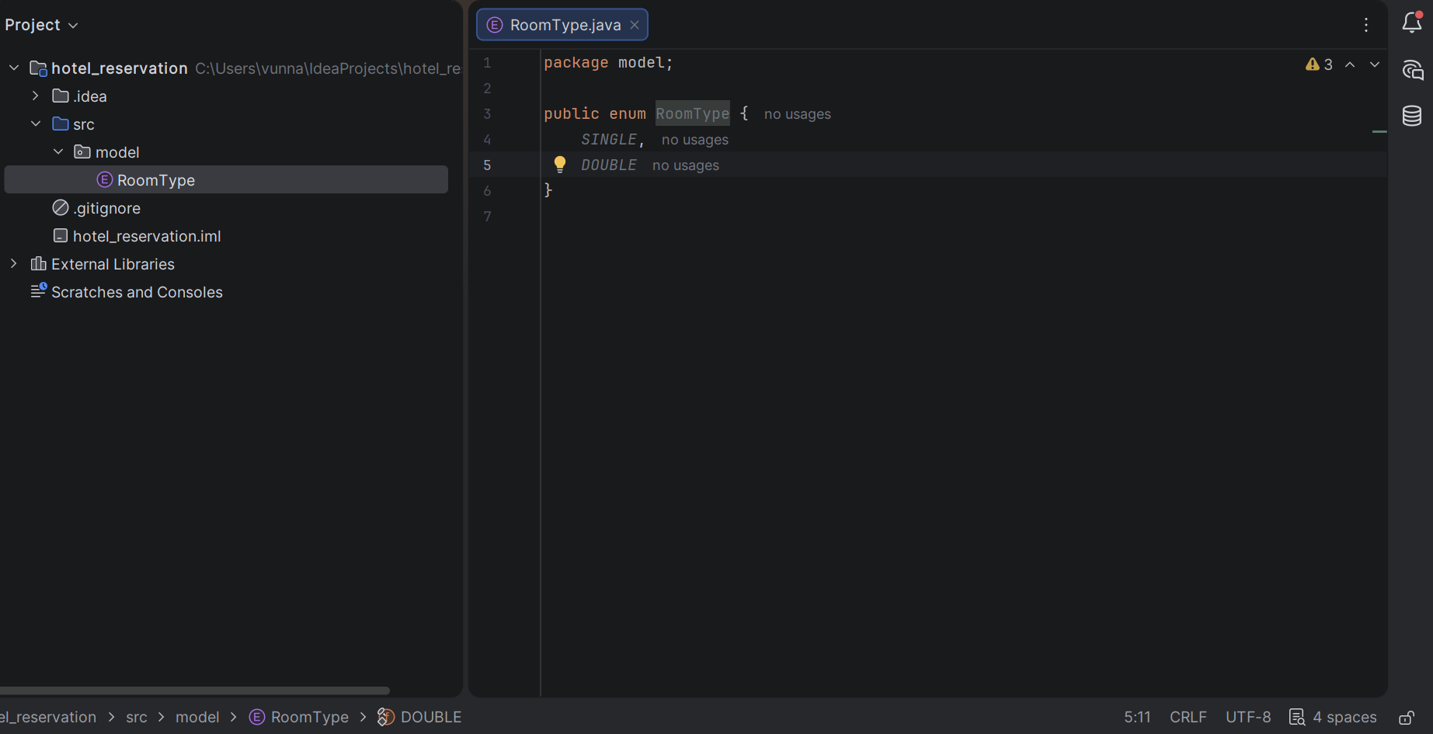

**Step 4: Create IRoom Interface**

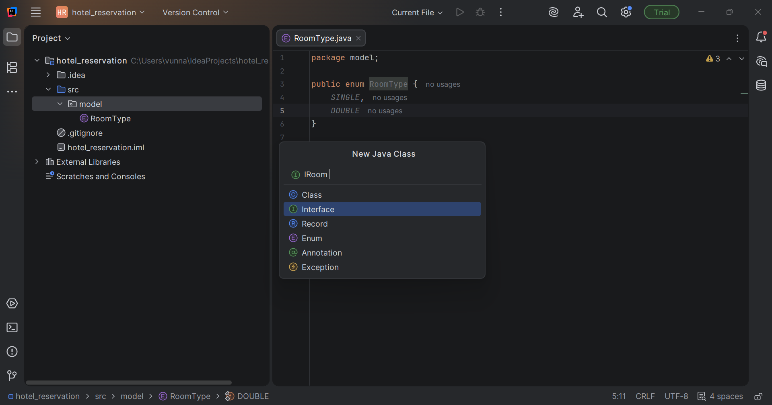

**Step 5: Interface created and polymorphism satisfied**

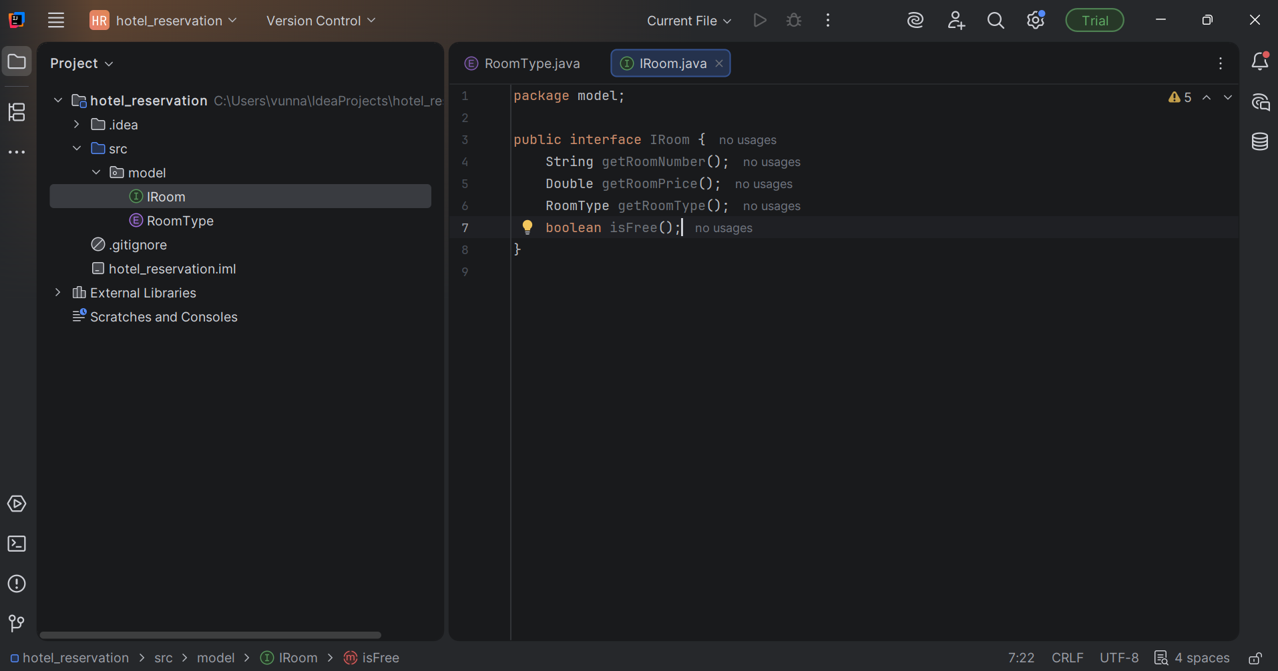

**Step 6: Create Room class**

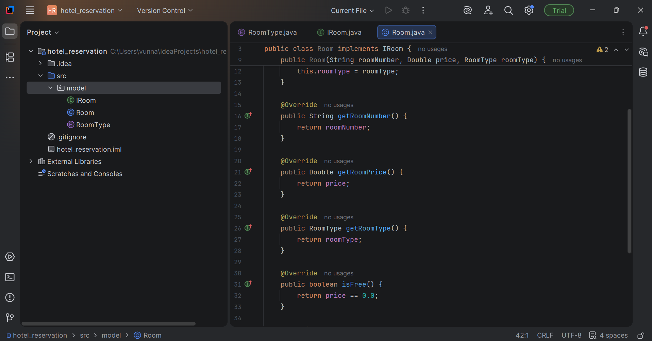

**Step 7: Create Freeroom class**

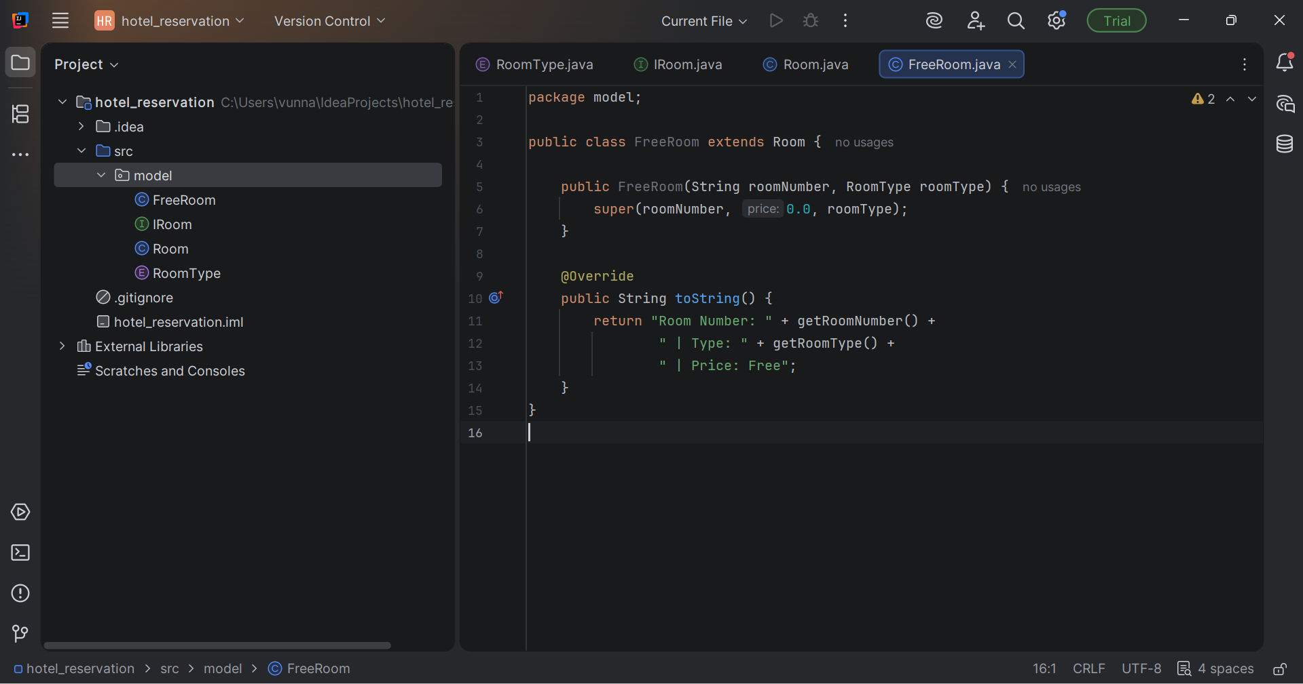

**Step 8: Create Customer class**

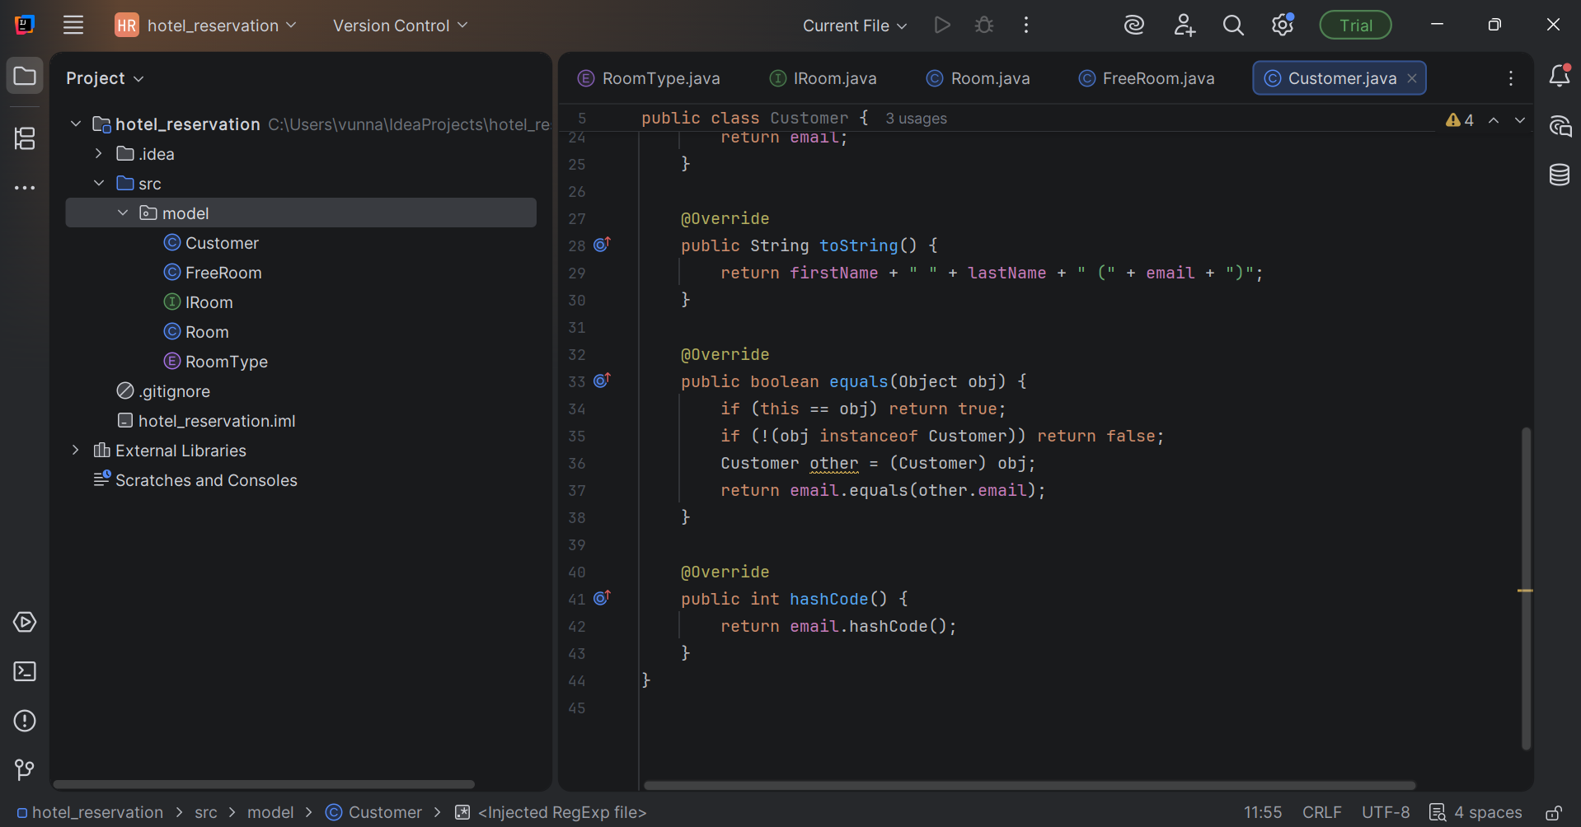

**Step 9: Create Reservation class**

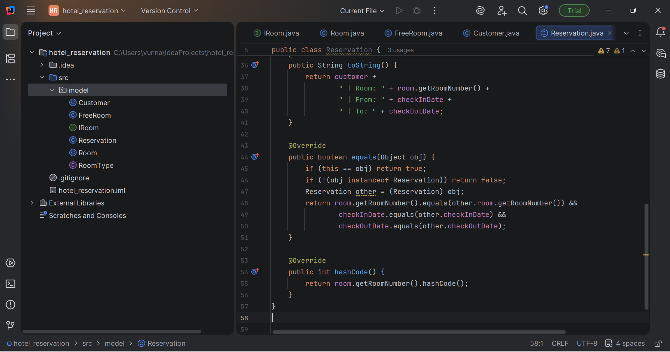

**Step 10: Create new service package:**

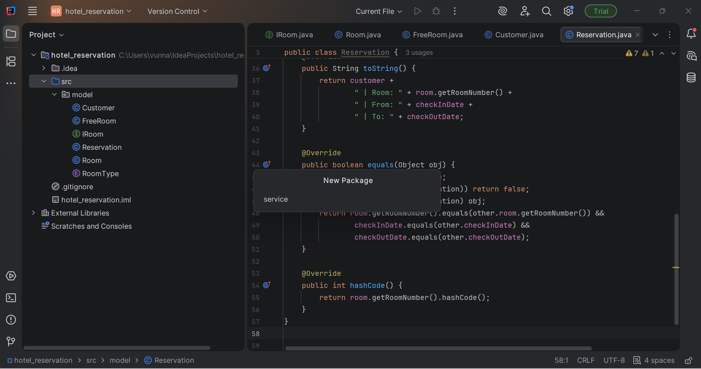

**Step 11: Create CustomerService (Singleton)**

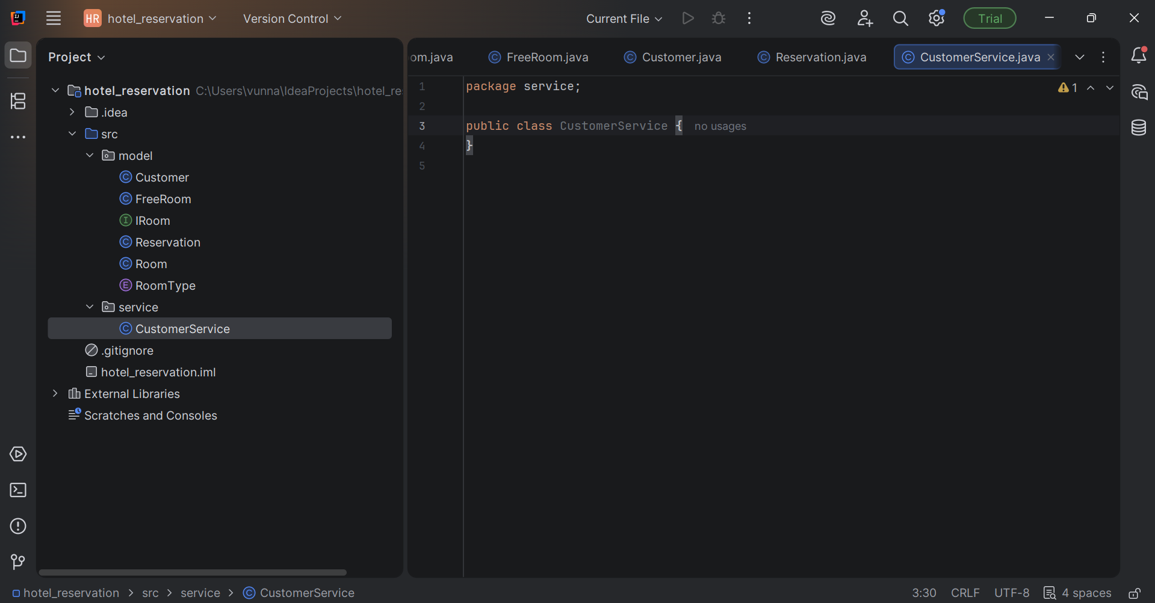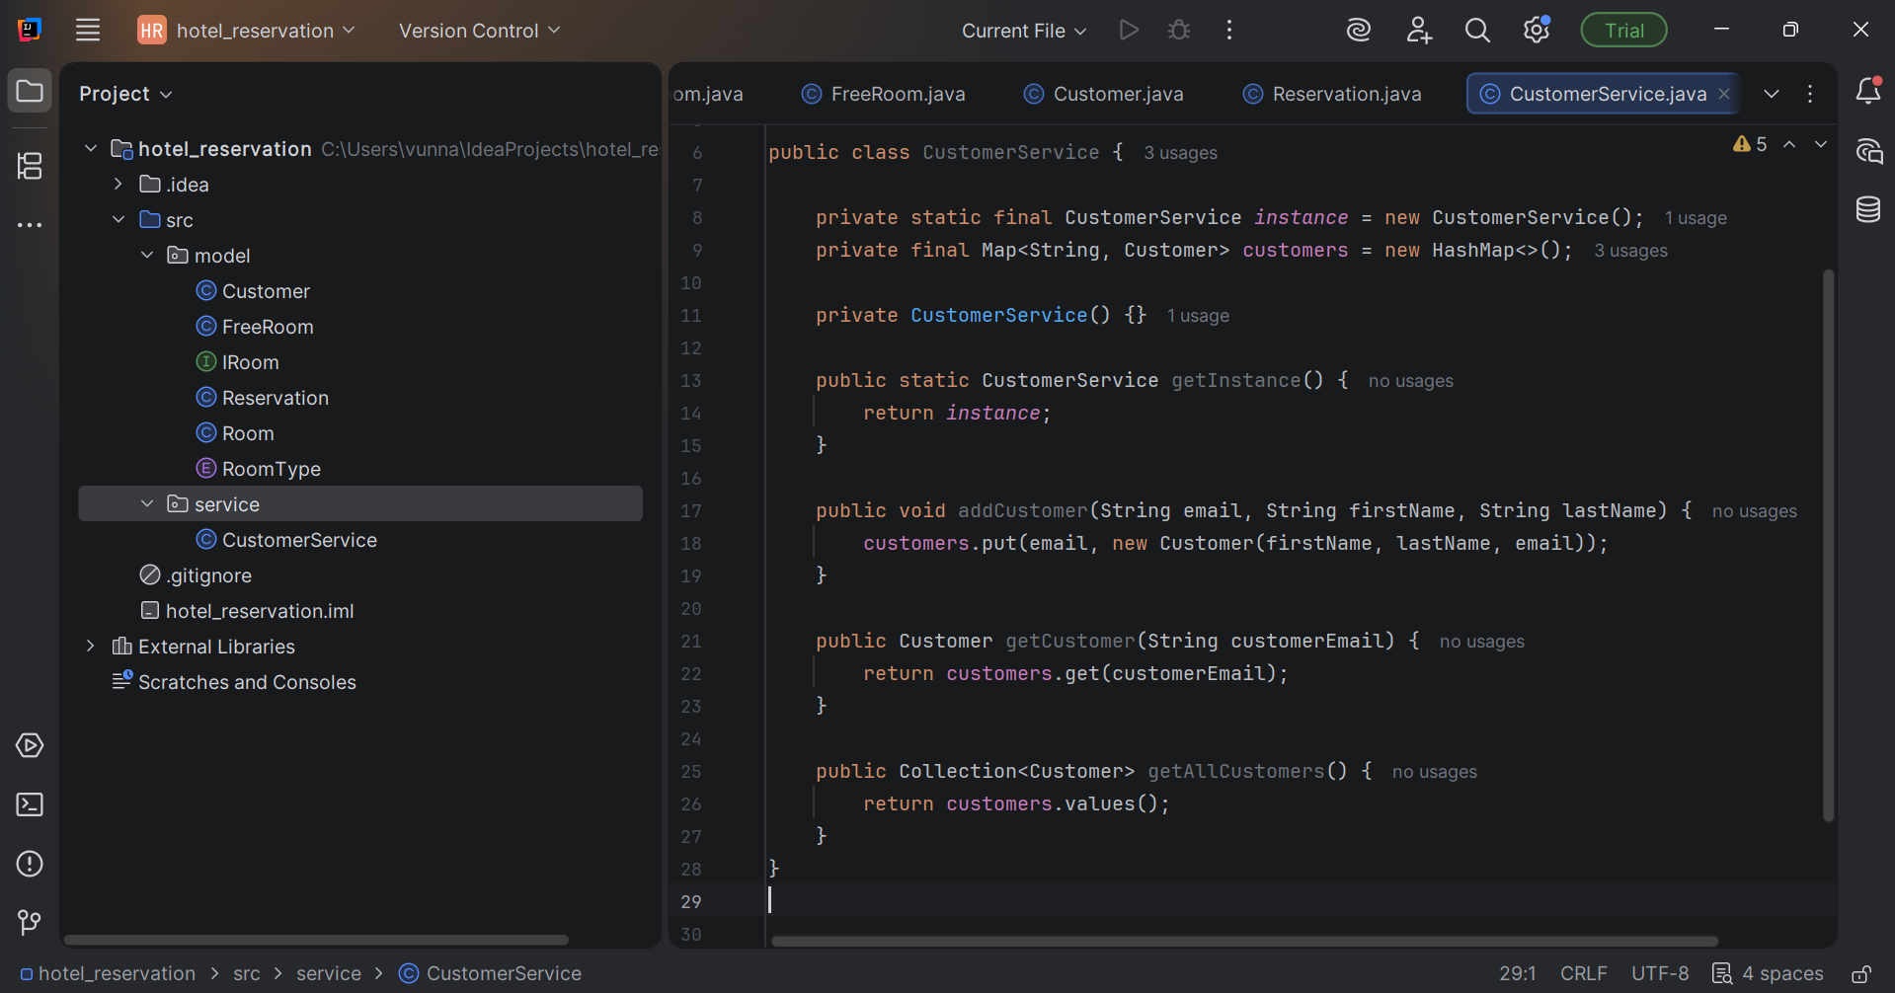

**Step 12: Create ReservationService**

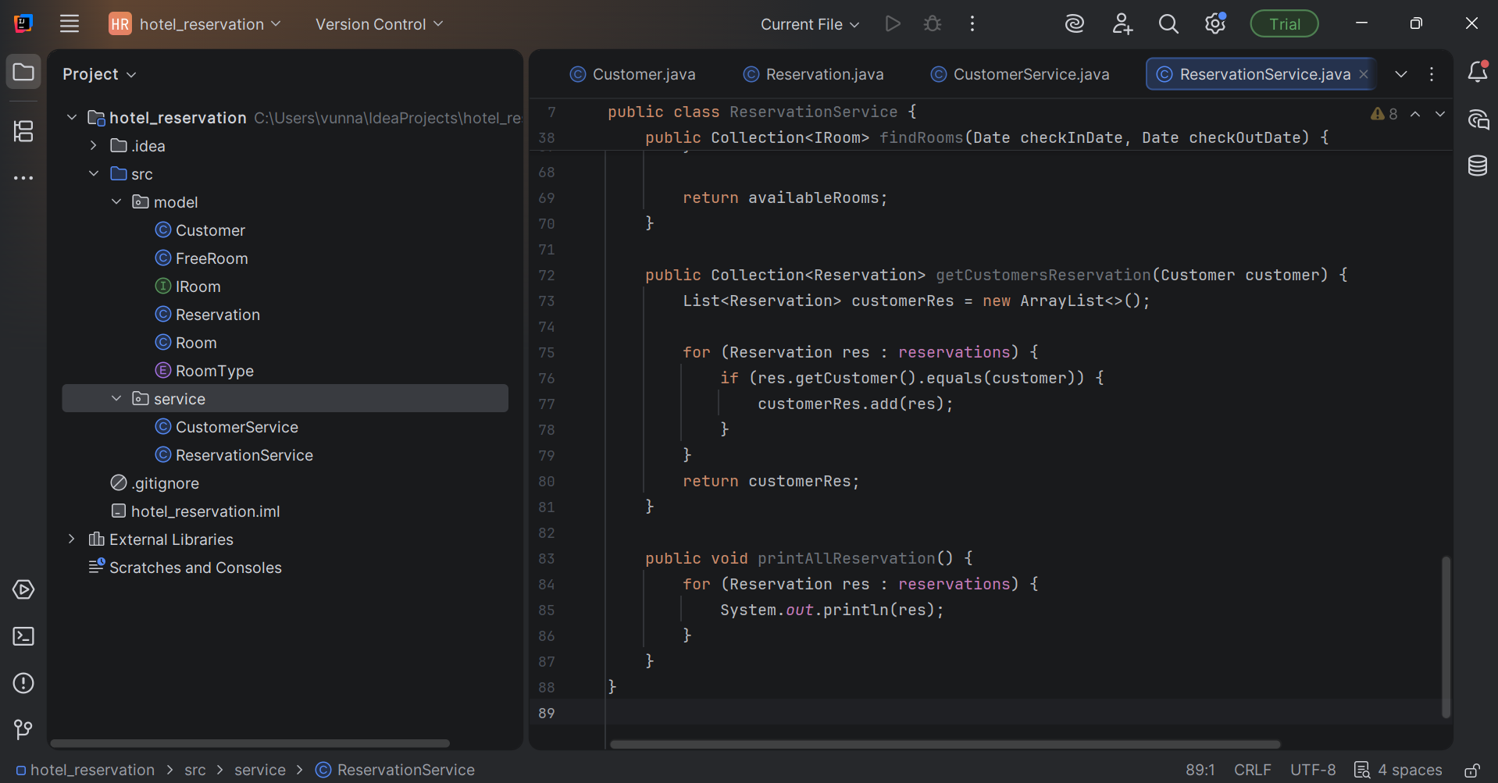

**Step 13: Create API Package**

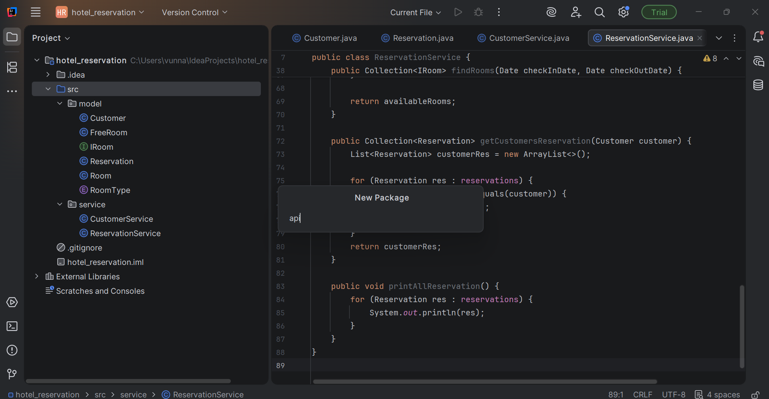

**Step 14: Create Hotel Resource**

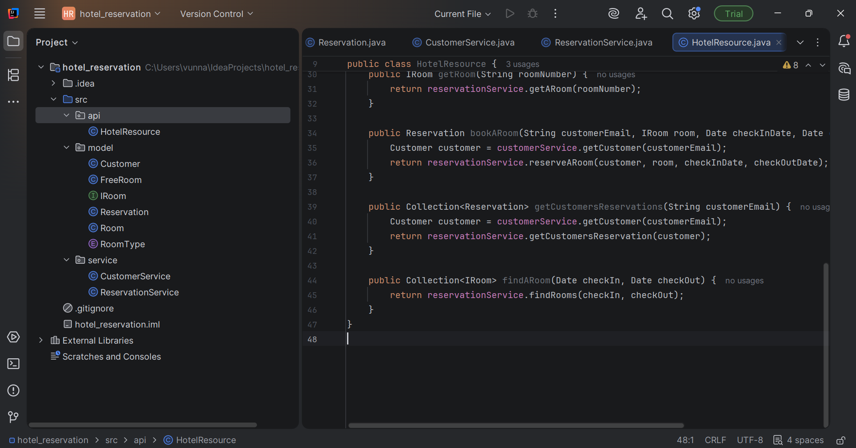

**Step 15: Create Admin Resource:**

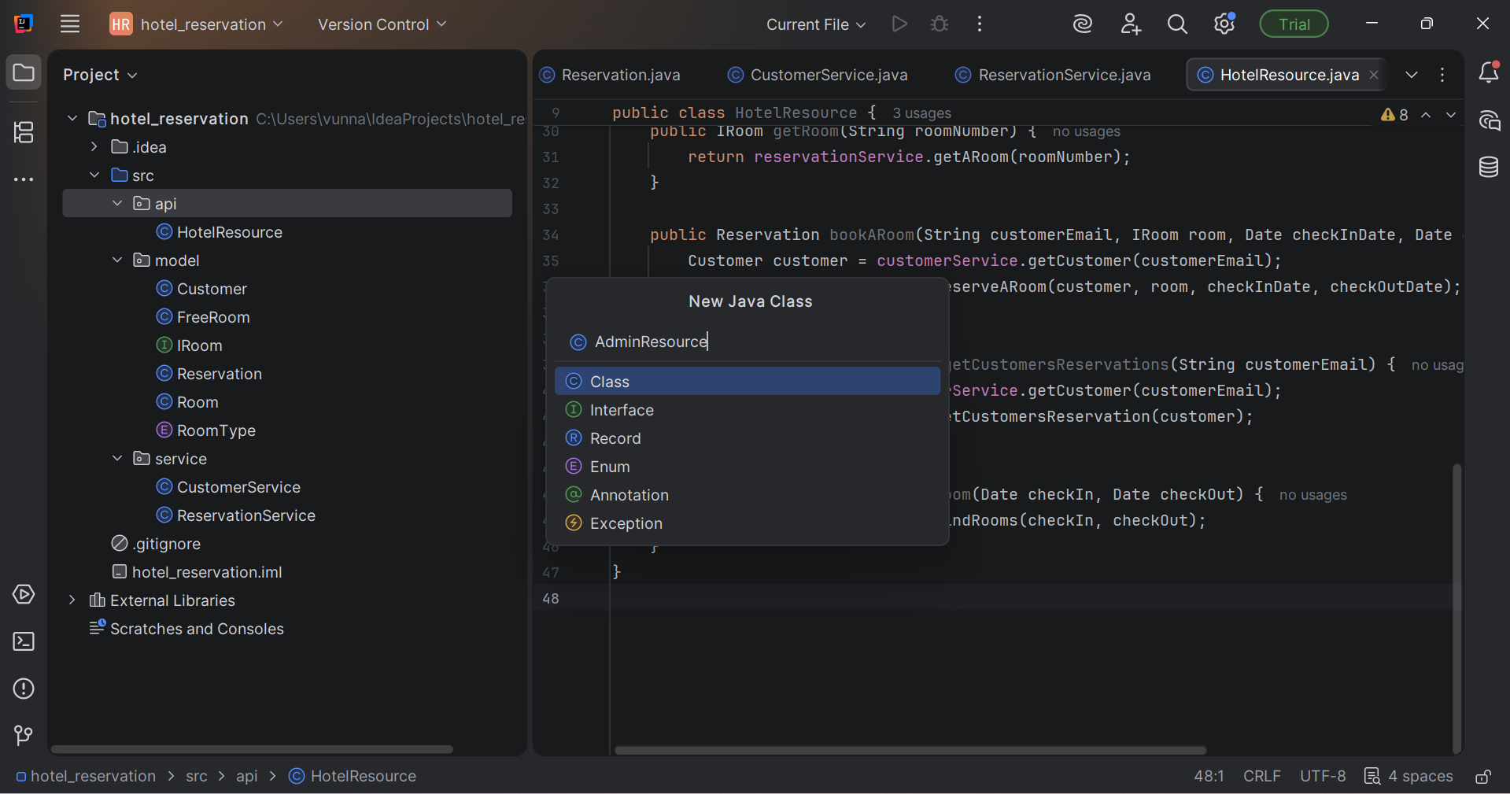

**Step 16: Create Menu Package and create adminmenu class**

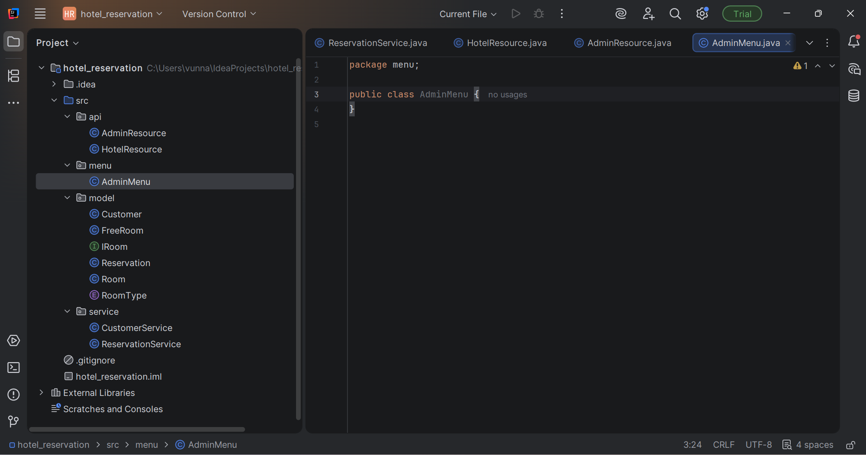

**Step 17: Craete mainmenu**

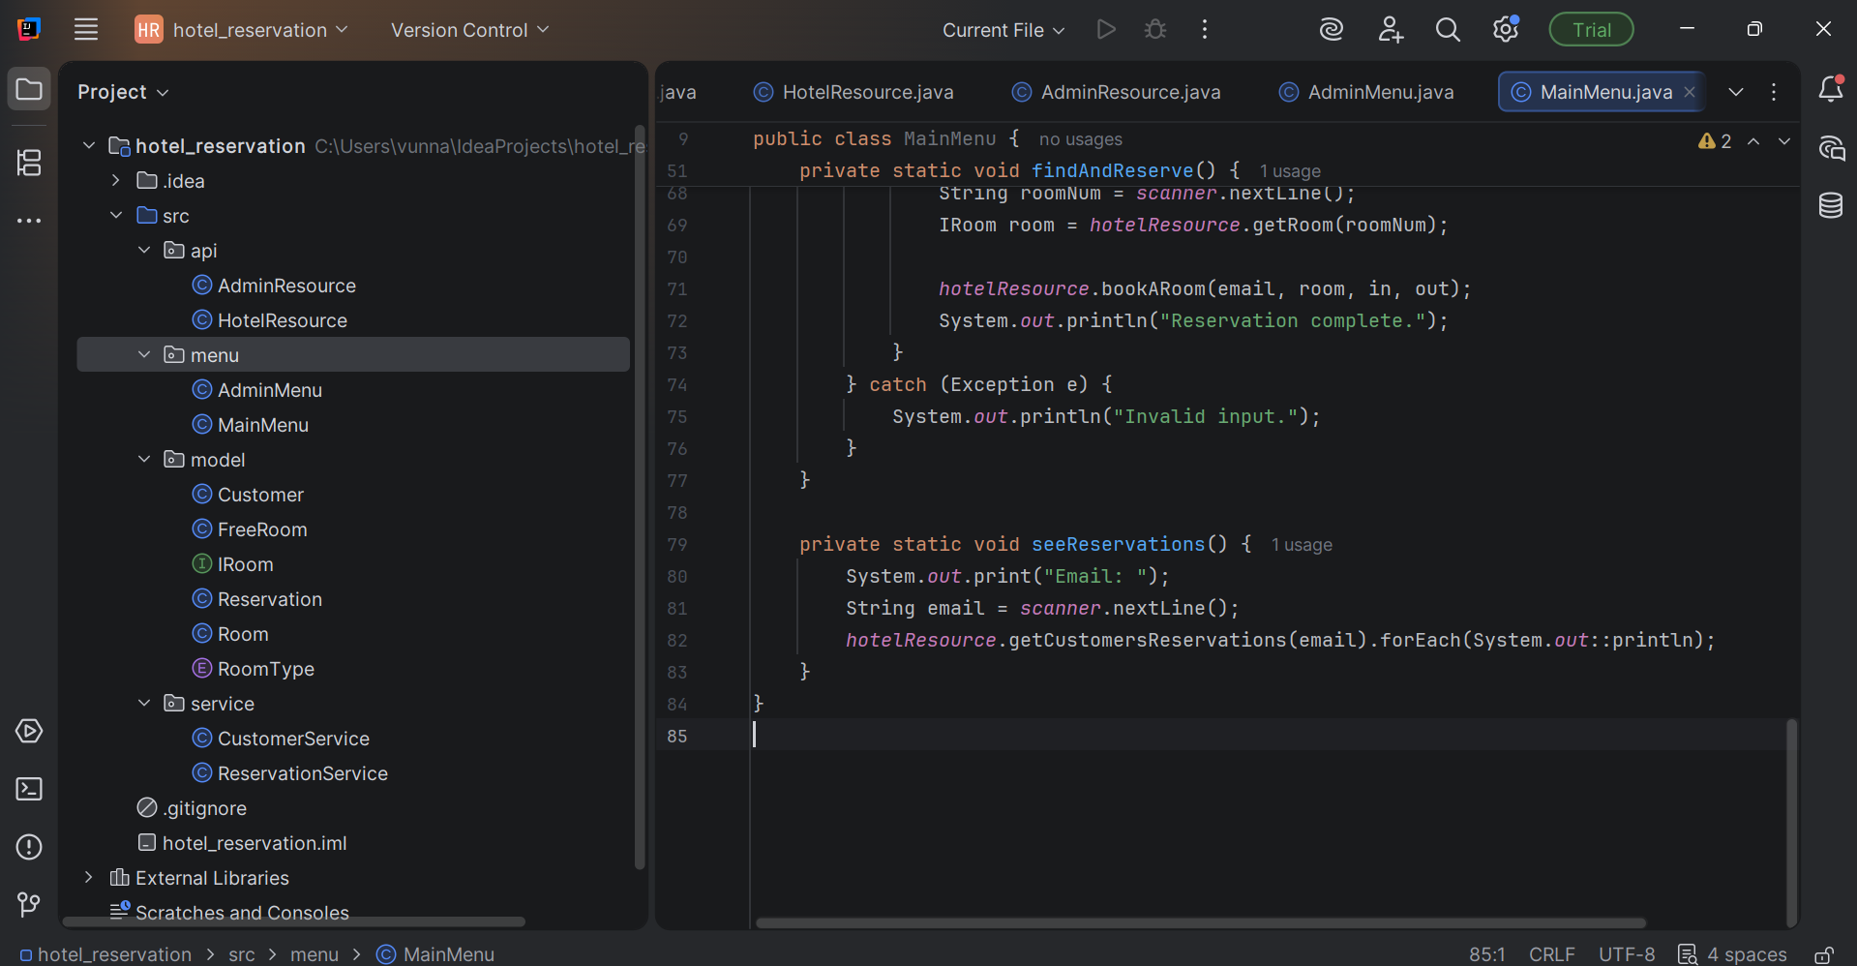

**Step 18: Create Final Main Class**

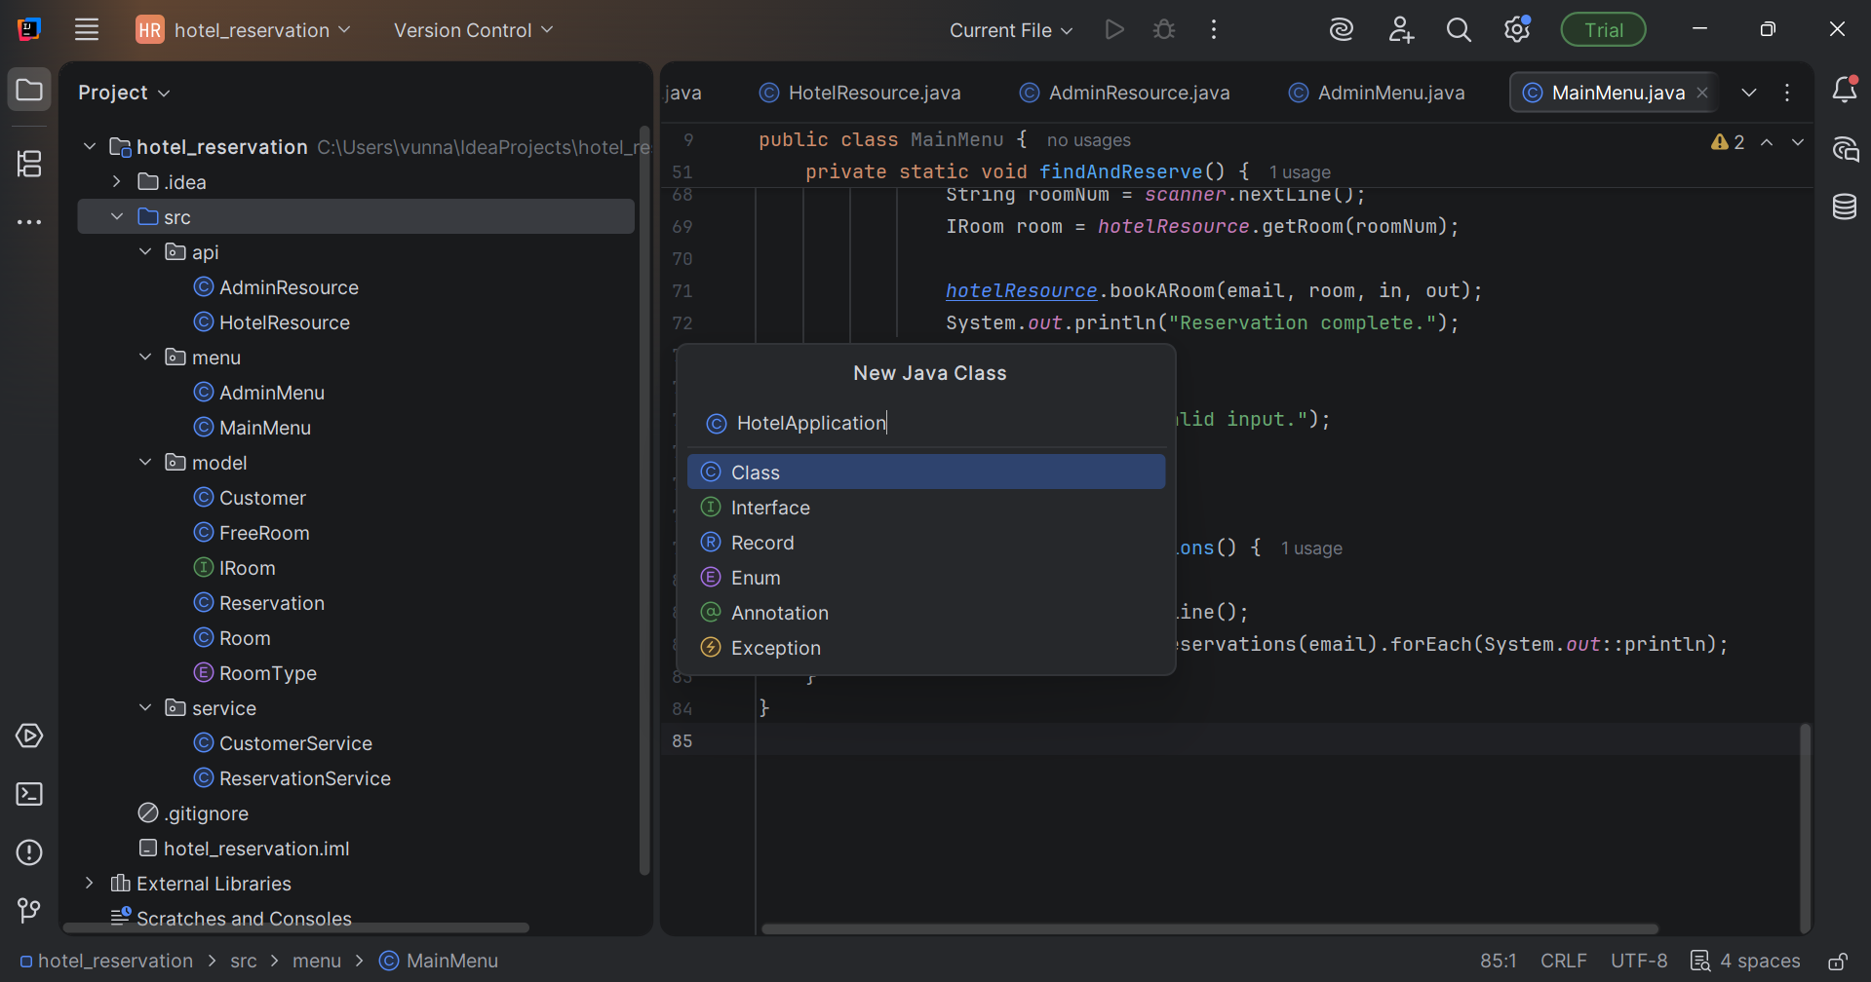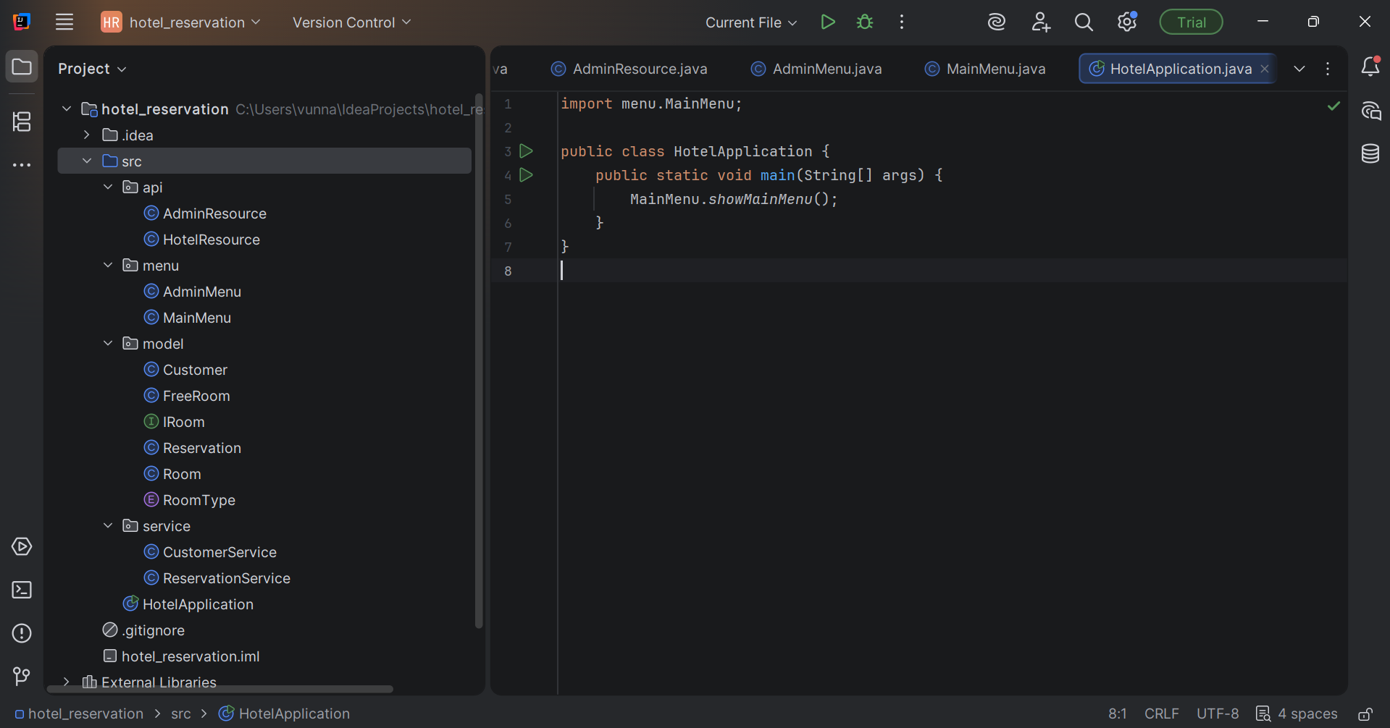

**Step 19: Run the code for testing**

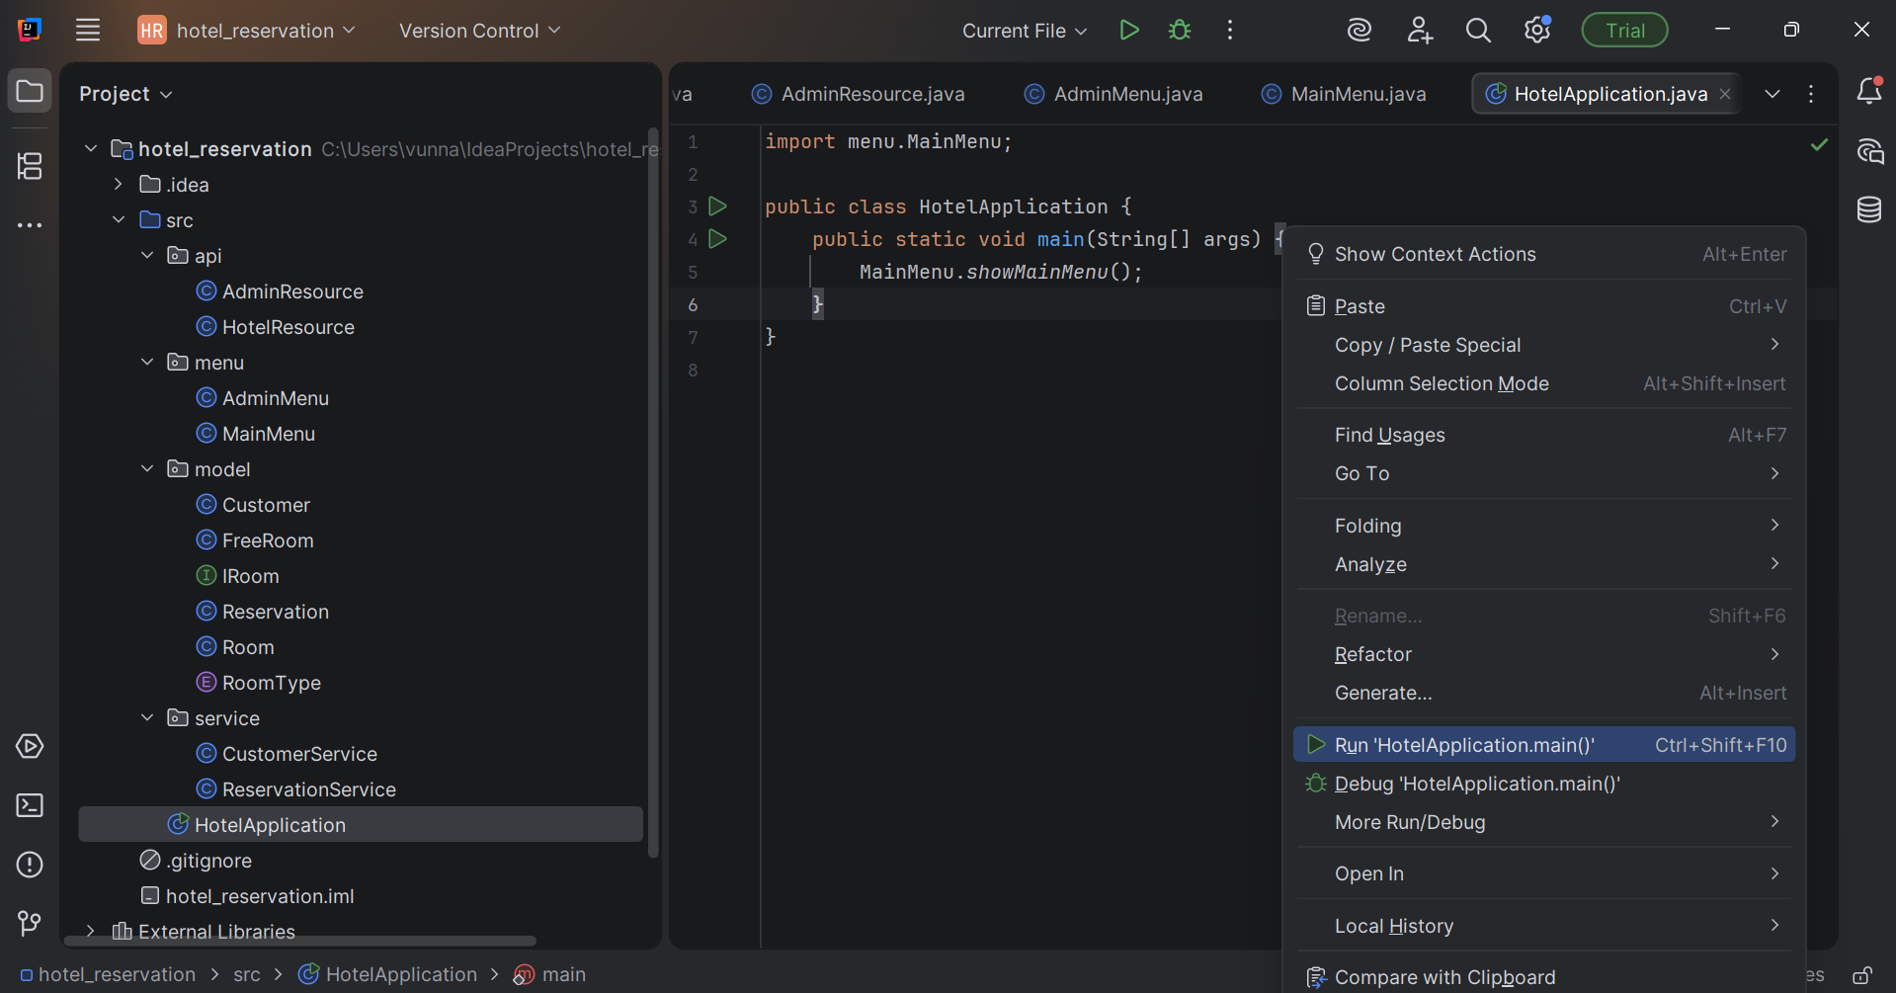

**Step 20: Output in the console window**

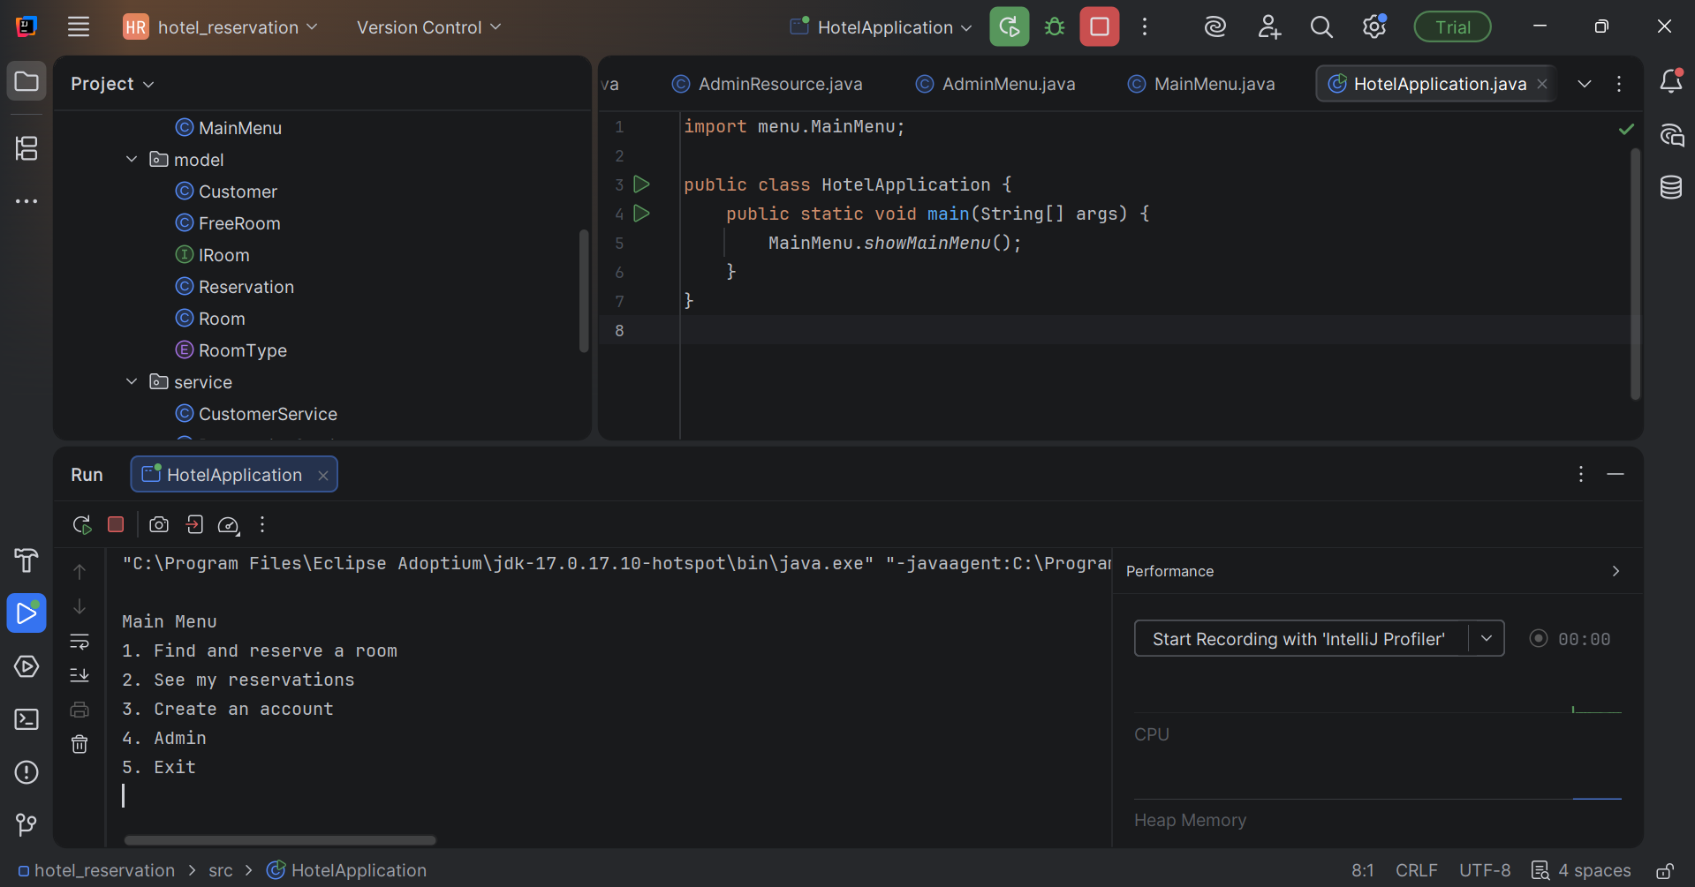

**Step 21: Testing of the menu functionality are working:**

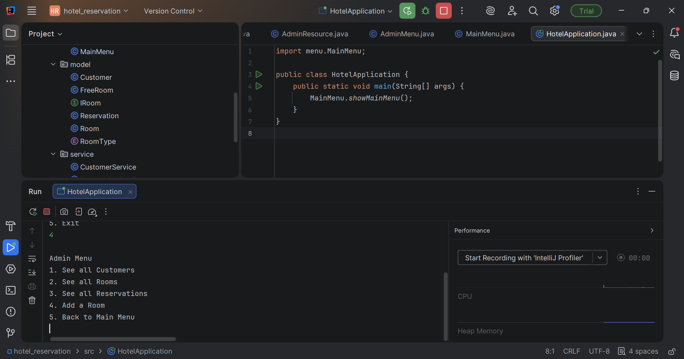

**Step 22: Checking add room function**

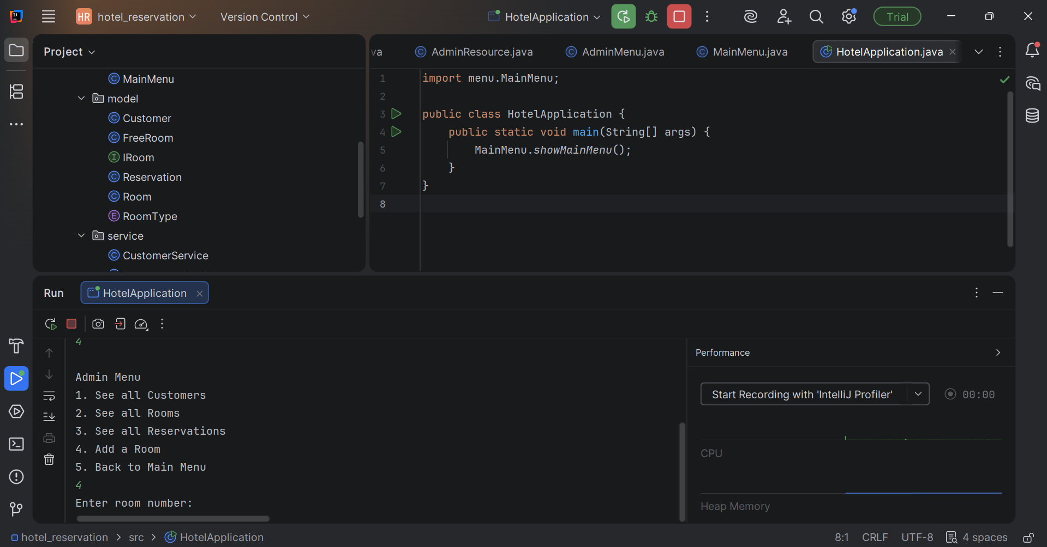

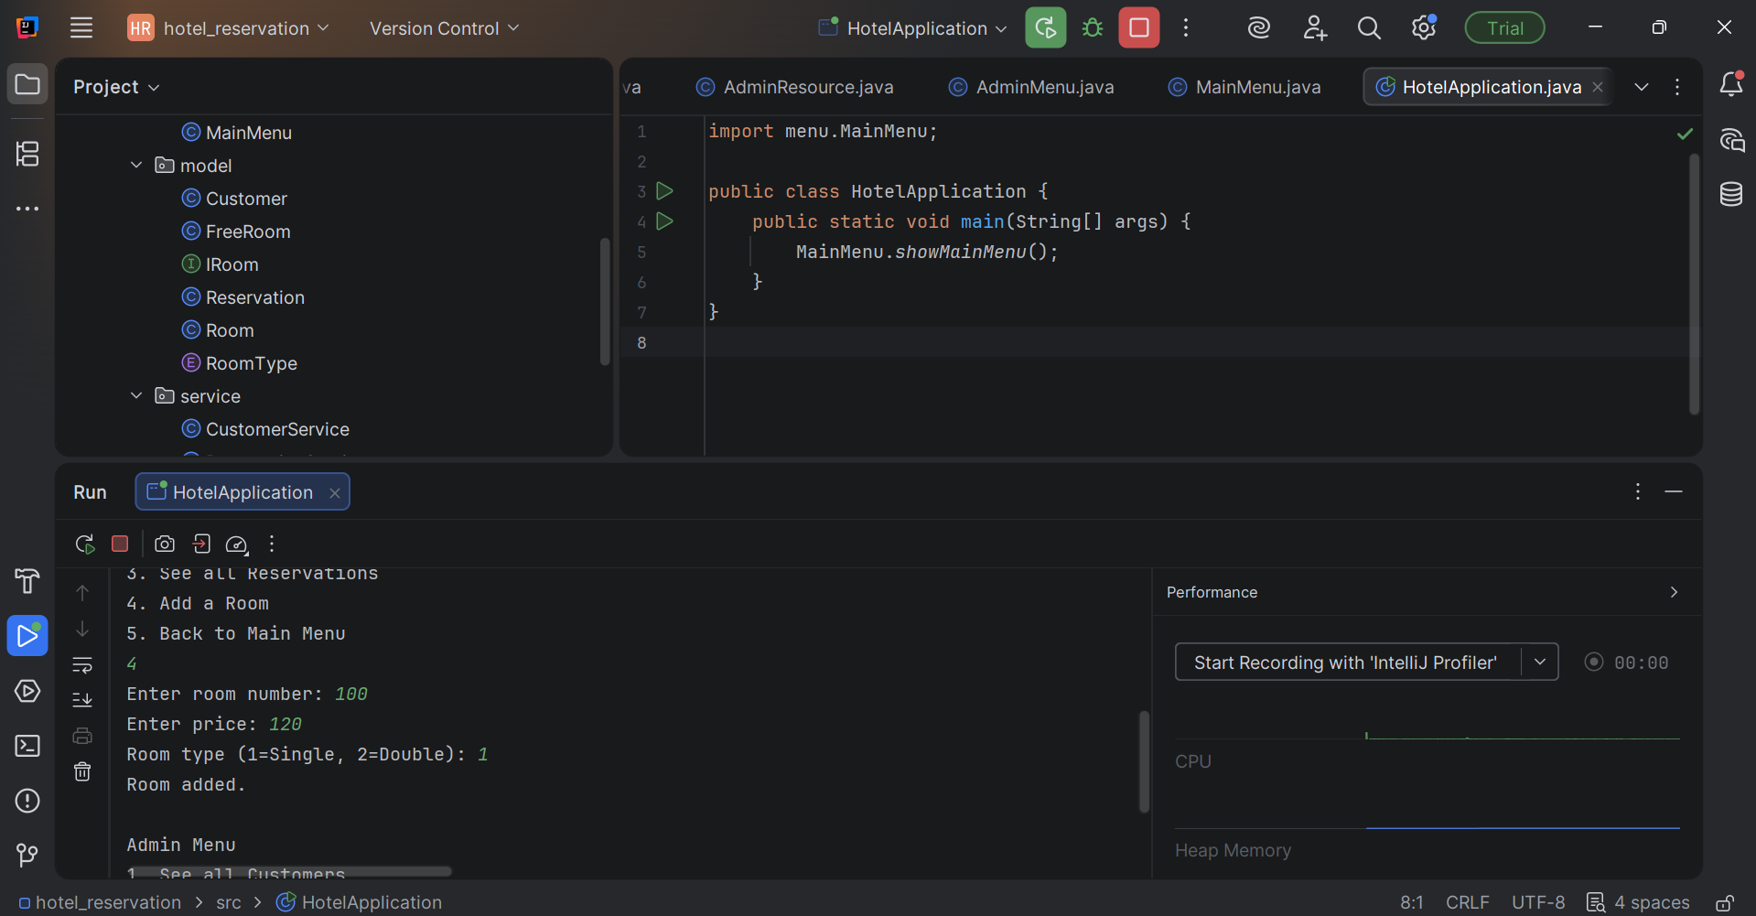

**Step 23: Checking the back to main room functionality and other tests:**

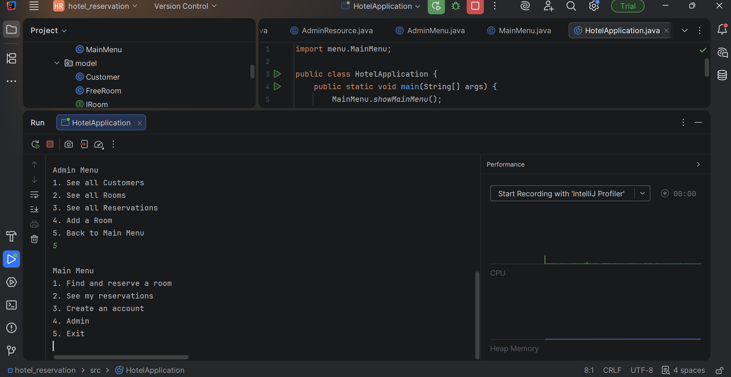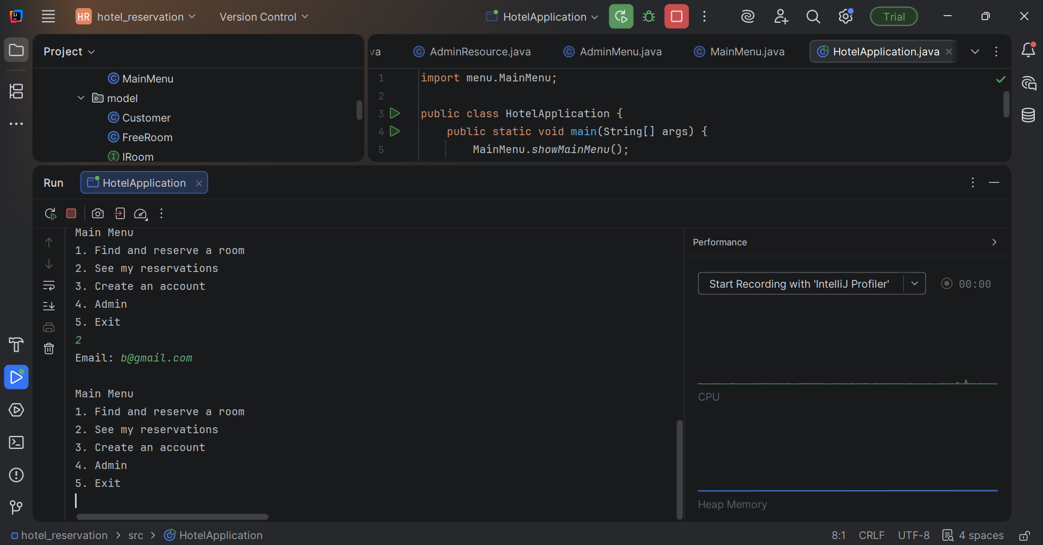

**Invalid Account Infor: (Email in incorrect format)**

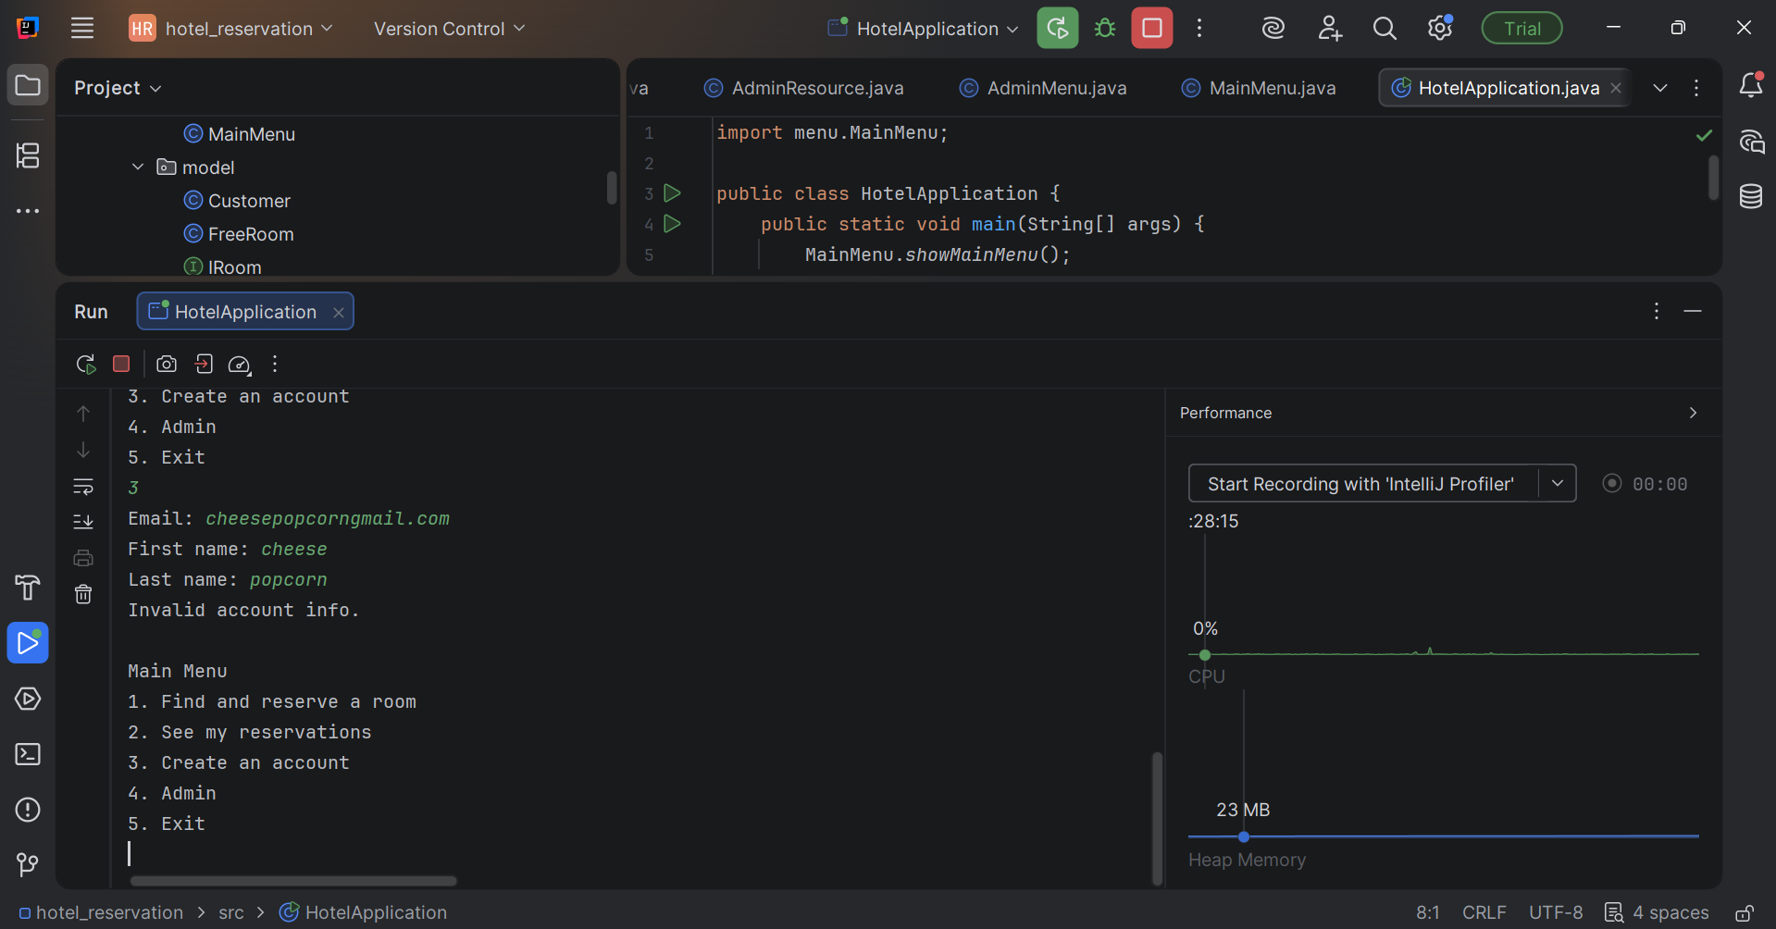

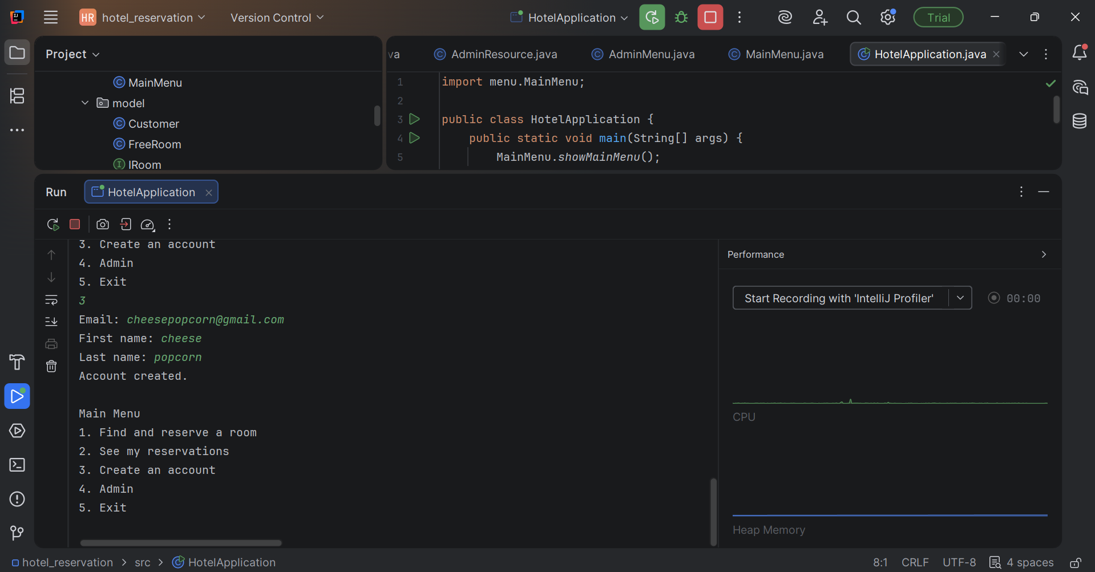

**Additional Functionality Added**

In addition to meeting all required project rubric criteria, the following functionality was implemented to improve user experience, system robustness, and real-world behaviour of the application:

1. **Prevention of Duplicate Customer Accounts**  
   The application checks whether an email address already exists before creating a new customer account. If the email is already registered, the system prevents duplicate account creation.
2. **Existing Account Options Menu**  
   When a user attempts to create an account with an existing email, the application provides the following options:
   * Reserve a room
   * View existing reservations
   * Return to the main menu

This allows users to continue without restarting the application.

1. **Guided Account Creation During Booking**  
   If a user tries to reserve a room without an account, the system prompts the user to create an account and allows them to retry the reservation immediately after successful account creation.
2. **Smart Booking Retry Flow**  
   Users can:
   * Decline booking at any step
   * Decline account creation
   * Retry booking the same room after creating an account

This ensures smooth navigation and avoids dead-end workflows.

1. **Prevention of Double Room Booking**  
   The system prevents a room from being booked more than once for overlapping date ranges, even by different customers. Clear messages are displayed when a room is unavailable.
2. **Improved Administrative Feedback**  
   The Admin menu displays clear messages such as “No rooms found” and “No reservations found” when applicable and always returns safely to the menu.
3. **Accurate and Clear User Messages**  
   The application avoids false success messages and clearly informs users when:
   * A room is unavailable for selected dates
   * An account does not exist
   * Input is invalid